Marella Morad

Sprint 2 Stage
Estimation Reflection 2 – 64C

Table of Contents
Introduction: 2
Evidence 3
JIRA Borad Tasks – Link to Epic and Tasks 3
Build Web Page to allow Users to Add New Products 3
Build Web Page to allow Users to Edit Existing Products 4
Build Web Page to allow Users to Remove Existing Products 5
GitHub Pull Requests: 6
Products Home + Add Product Web Pages - Link to PR 6
Edit and Soft Delete Existing Products – Link to PR 6
Accuracy of Estimation: 7
Reasons for Accuracy: 7
Having completed a Similar Task in Sprint 1: 7
Use of “Estimating by Analogy” Technique: 7
Thorough Analysis of Differences: 7
Realistic Contingency: 7
Improvements for Future Estimations: 7
Detailed Analysis: 7
Historical Data: 7
Collaboration: 8
Adjust Contingency: 8
Conclusion: 8

Introduction:
In Sprint 2, I undertook the task of developing the “Product Management Web Pages” epic and estimated the effort required using the “Estimating by Analogy” technique. The initial estimation was 7 hours, and I completed the task in 6.5 hours. In this reflection report, I will analyse the accuracy of my estimation and discuss the reasons for this accuracy, as well as suggest ways to improve future estimations.
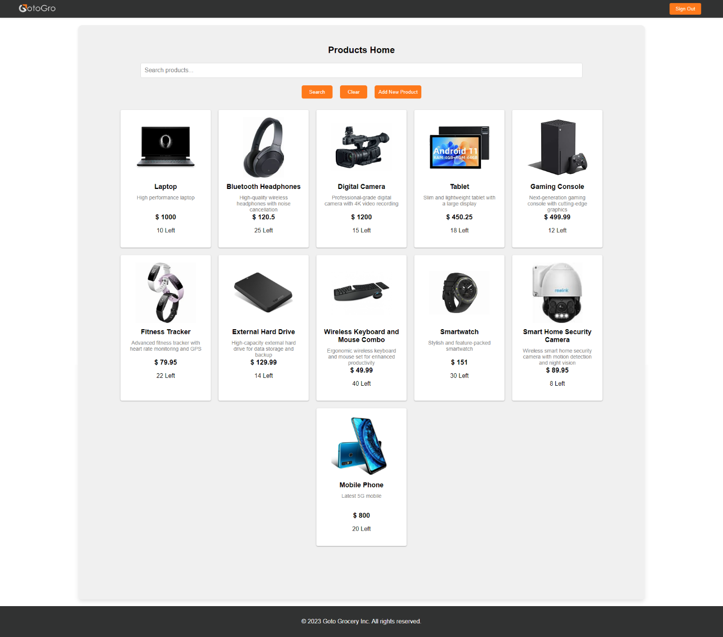

Evidence

JIRA Borad Tasks – Link to Epic and Tasks

Build Web Page to allow Users to Add New Products
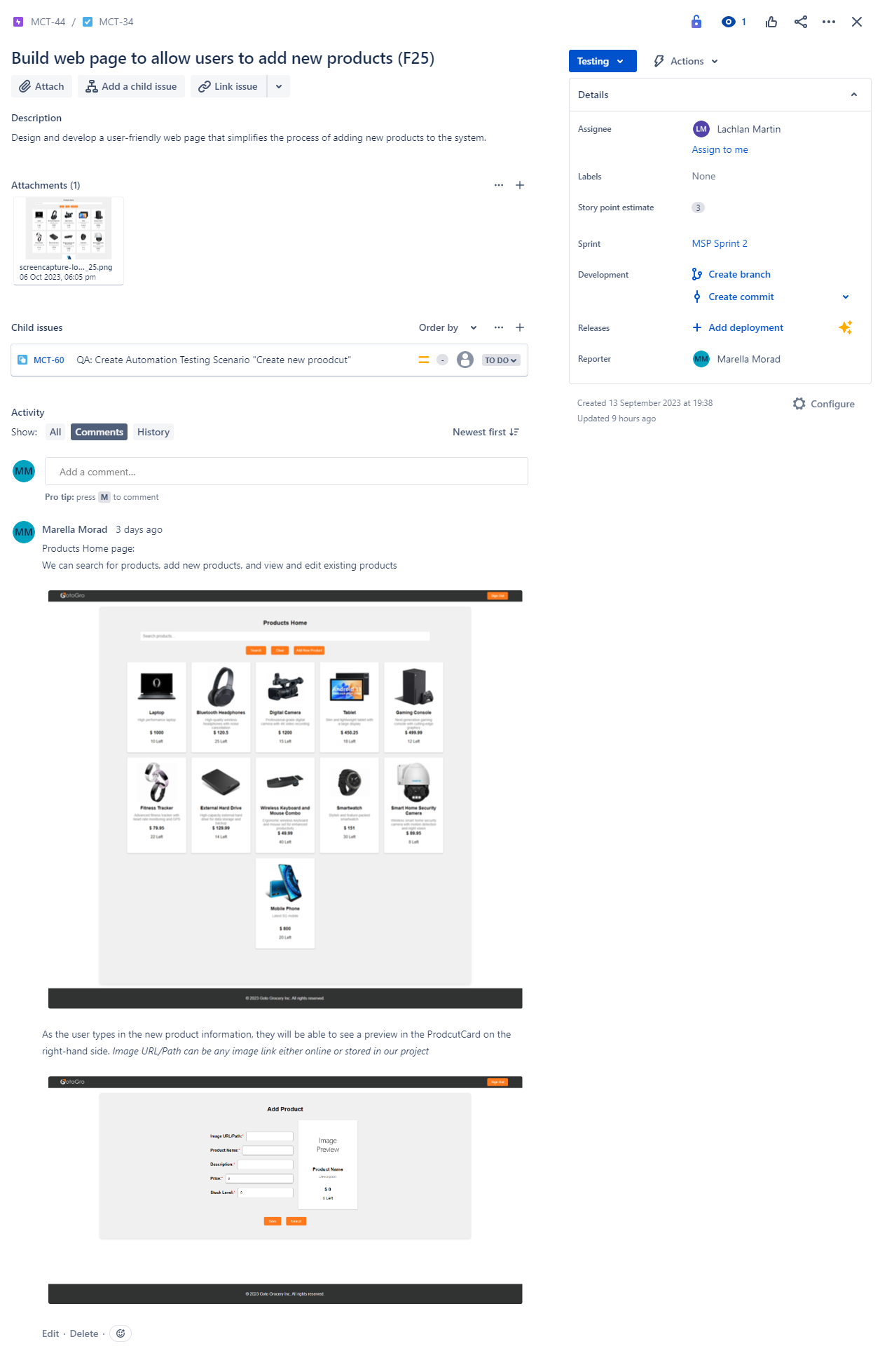

Build Web Page to allow Users to Edit Existing Products
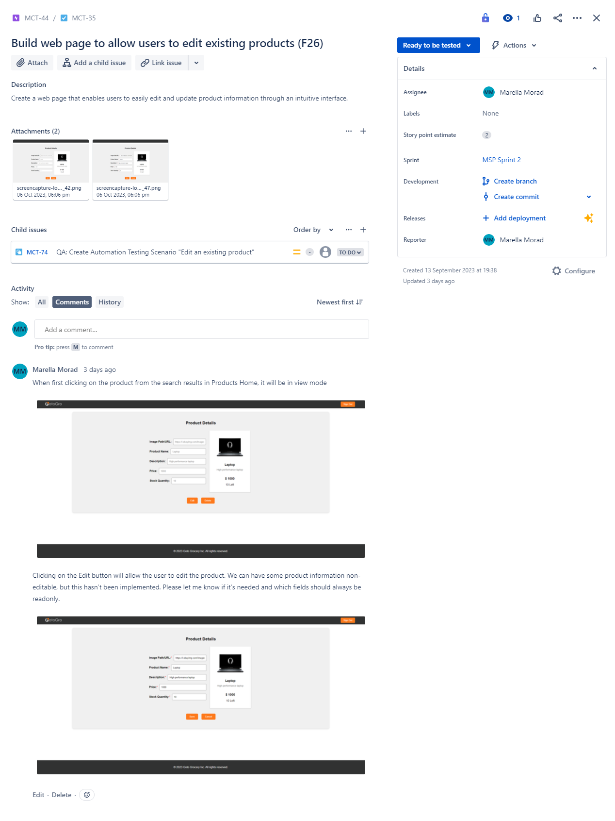

Build Web Page to allow Users to Remove Existing Products
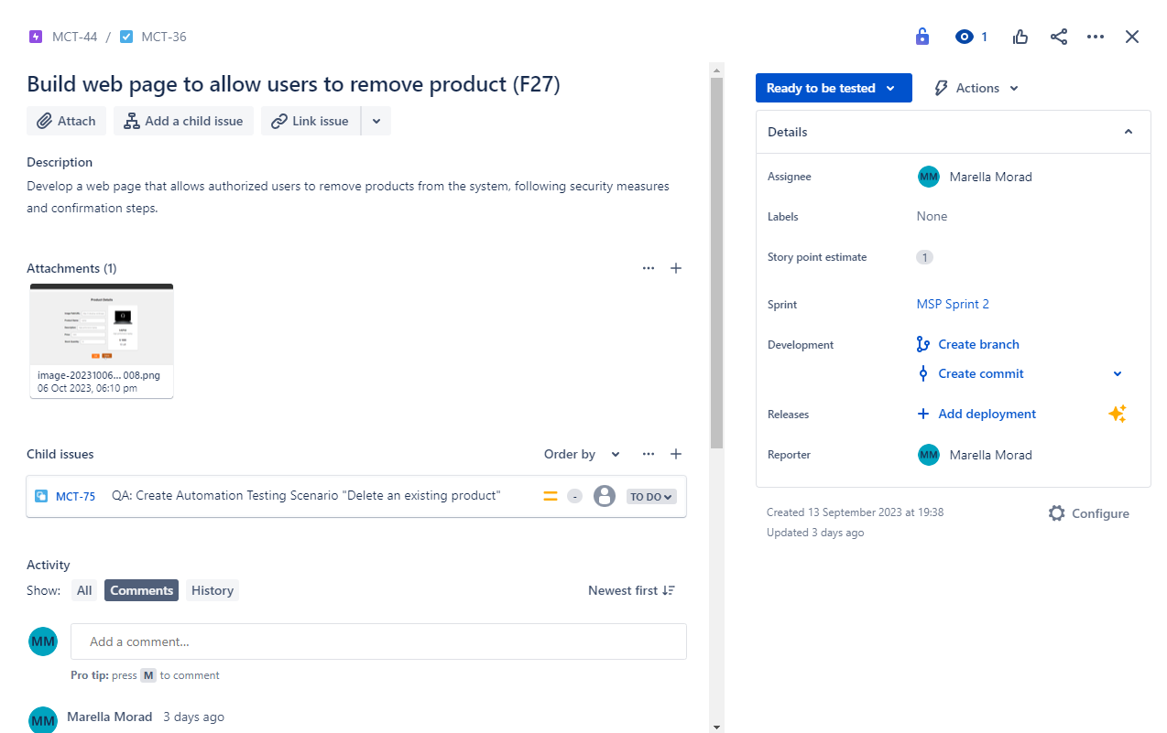
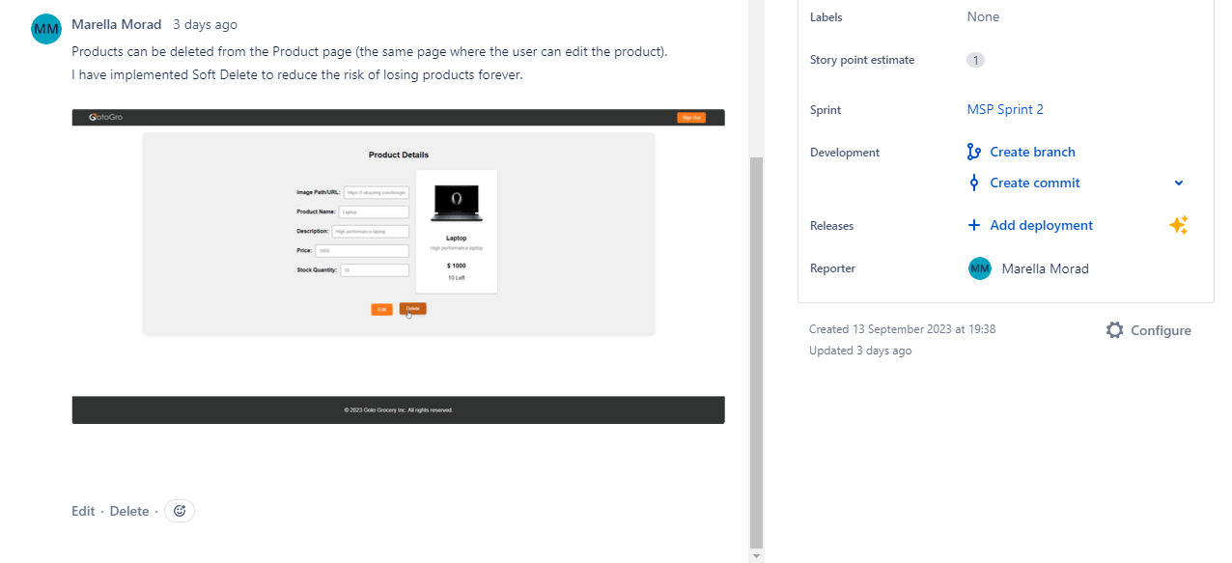

GitHub Pull Requests:

Products Home + Add Product Web Pages - Link to PR
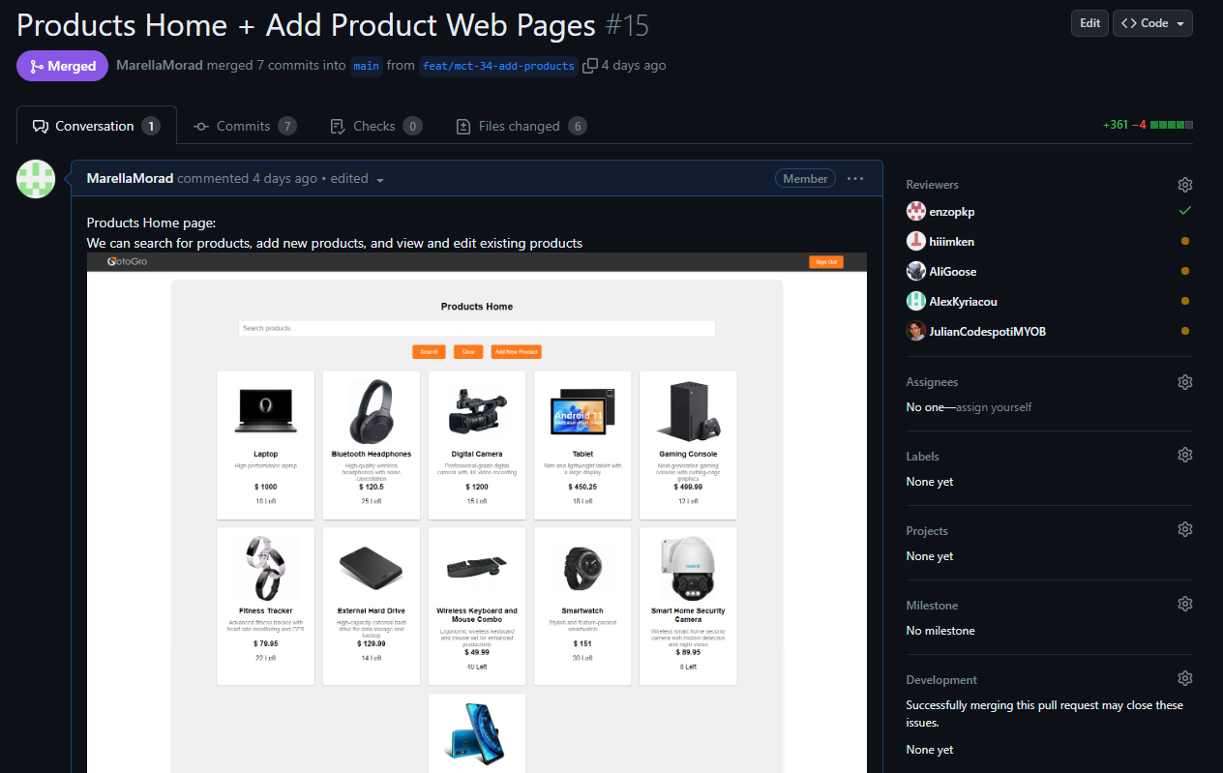

Edit and Soft Delete Existing Products – Link to PR
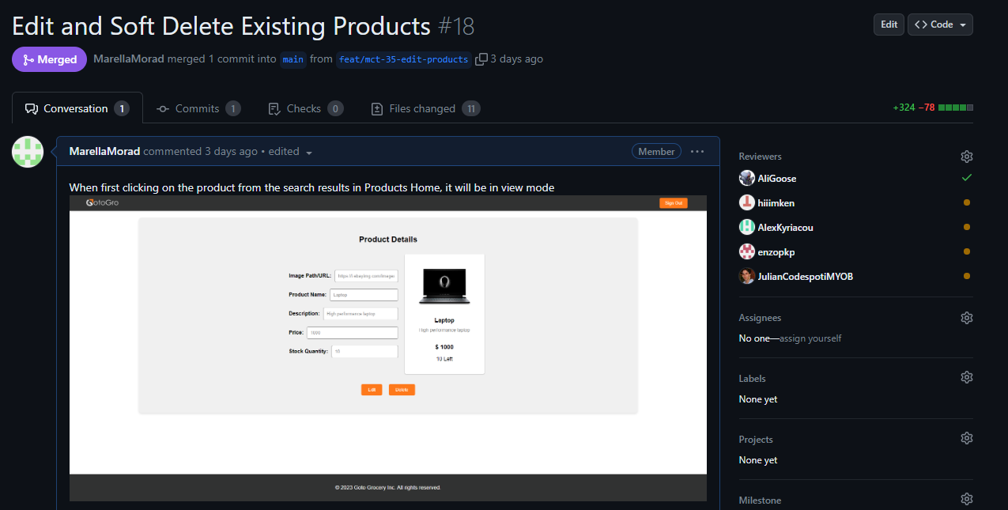

Accuracy of Estimation:
The actual effort of 6.5 hours falls within 10% of my original estimate of 7 hours. Therefore, I can conclude that my estimation was reasonably accurate for this sprint backlog item which is an improvement from the previous estimation in task 61C for Sprint 1 backlog item. This level of accuracy can be attributed to several factors:

Reasons for Accuracy:

Having completed a Similar Task in Sprint 1:
One of the key reasons for the accuracy of my estimation was the experience gained from a similar task in Sprint 1, the “Member Management Web Pages”. Since both tasks involved designing and developing web pages with similar functionality and integration requirements, my experience from the first task allowed me to estimate the second task more accurately.

Use of “Estimating by Analogy” Technique:
The "Estimating by Analogy" technique proved effective in this case. By drawing parallels between the two tasks, I could identify commonalities and differences, which guided my estimation process. This technique leveraged my past experience and reduced estimation errors.

Thorough Analysis of Differences:
I accurately identified the differences between the two tasks, mainly the incorporation of product images. By estimating an additional hour for this specific modification, I accounted for the extra effort required for this unique feature accurately.

Realistic Contingency:
In my initial estimate, I did not allocate a significant amount of contingency time because I had confidence in the existing project foundations. However, I did acknowledge the potential for variations, which allowed for a slightly flexible estimate.

Improvements for Future Estimations:
While my estimation for this sprint was accurate, there is always room for improvement to ensure consistently precise estimates in future sprints.

Detailed Analysis:
Continue to conduct a thorough analysis of the similarities and differences between the current task and past tasks especially if they have similarities. This analysis should include not only functionality but also any potential challenges or complexities that may arise during development.

Historical Data:
Maintain a record of past estimation accuracy to better inform future estimations. This historical data can help identify patterns and trends in estimation accuracy and allow for adjustments as needed.

Collaboration:
Seek input from team members who have experience with similar tasks, for example, if another team member had completed the Member Management Web Pages task, it would’ve been wiser to seek their advice about this estimation rather than estimating it myself without previous experience. Collaborative estimation can provide different perspectives and insights, leading to more accurate estimates.

Adjust Contingency:
Depending on the level of uncertainty, consider adjusting the contingency time in the estimation. While it's essential to maintain a realistic estimate, a slightly wider contingency can account for unexpected challenges.

Conclusion:
In summary, my effort estimation for the "Product Management Web Pages" task during Sprint 2 proved to be reasonably accurate, falling within 10% of the actual effort required. This level of precision was the result of a combination of factors, including my experience, a thorough analysis of the task, and a pragmatic approach to contingency planning.
Looking ahead, I am committed to further enhancing my estimation skills for future sprints. This involves a commitment to detailed task analysis, leveraging historical data to inform estimates, fostering collaboration within the team to gain diverse insights, and remaining flexible in adjusting contingency time when necessary. By continuously learning and refining my estimation capabilities, I aspire to consistently deliver accurate estimations, thereby contributing significantly to the success of our ongoing projects.

